Audacity Animal Poem Project (Voiceover/sFx)
Visit Ken Nesbitt’s poetry page for kids. You will locate a poem that you will narrate and add sound effects for.
- http://www.poetry4kids.com/cat-Animal.html
You must sound animated/in character during the narration. No audio sound effect is allowed during your speaking part other than an echo or fade (no pitch or speed adjustments). Sound effects are required throughout the poem. And, a light musical instrumental should be in the background (use Envelope tool to turn it down).
Website for sound effects and instrumental music:
- http://classjump.com/s/skinner/documents/multimediafreesounds.htm
PRINT THE POEM (copy and paste to Word) and make notes ON THAT PAGE where you added a sound effect. (I just added a little icon--**) And note where you got your sound effects as well at the bottom!! attach that sheet!
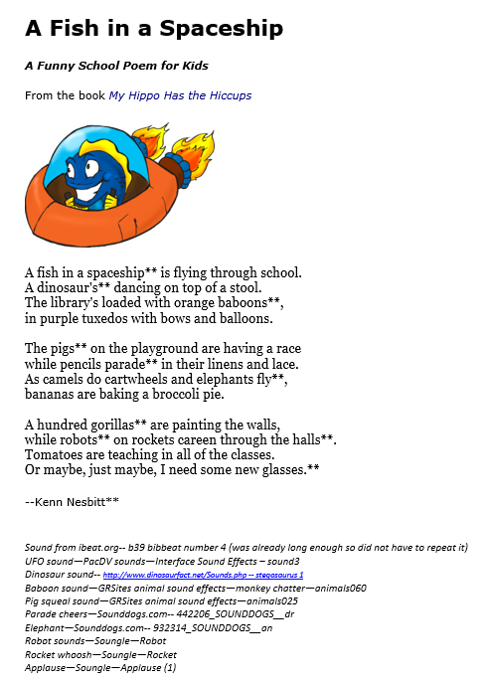
Your finished file must be exported as an MP3 file, scoring guide put in the tray with poem/notes attached, and the MP3 file emailed to me for grading (attached) to my skindawg2@gmail.com address.
Requirement | Points Possible | Deductions
High quality narration with personality/fun and easy to hear and understand | 5
Light musical instrumental throughout (turn down) | 5
Minimum of 8 sound effects added to give the story some “fun” (not too loud, not too quiet) | 10
Printout included with sounds noted and sources given | REQUIRED or no grade
MP3 format emailed to instructor by due date | 10
TOTAL | 30

Name:__________________________________
Poem: __________________________________ (attach poem with noted information!)

A Fish in a Spaceship
A Funny School Poem for Kids
From the book My Hippo Has the Hiccups
A fish in a spaceship** is flying through school.
A dinosaur's** dancing on top of a stool.
The library's loaded with orange baboons**,
in purple tuxedos with bows and balloons.
The pigs** on the playground are having a race
while pencils parade** in their linens and lace.
As camels do cartwheels and elephants fly**,
bananas are baking a broccoli pie.
A hundred gorillas** are painting the walls,
while robots** on rockets careen through the halls**.
Tomatoes are teaching in all of the classes.
Or maybe, just maybe, I need some new glasses.**
--Kenn Nesbitt**

Sound from ibeat.org-- b39 bibbeat number 4 (was already long enough so did not have to repeat it)
UFO sound—PacDV sounds—Interface Sound Effects – sound3
Dinosaur sound-- http://www.dinosaurfact.net/Sounds.php -- stegosaurus 1
Baboon sound—GRSites animal sound effects—monkey chatter—animals060
Pig squeal sound—GRSites animal sound effects—animals025
Parade cheers—Sounddogs.com-- 442206_SOUNDDOGS__dr
Elephant—Sounddogs.com-- 932314_SOUNDDOGS__an
Robot sounds—Soungle—Robot
Rocket whoosh—Soungle—Rocket
Applause—Soungle—Applause (1)

