Audacity Help Sheet
Essentials
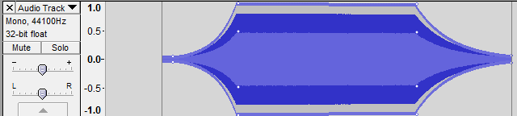
“Import” audio; do not OPEN audio files to edit!
Play/Stop Spacebar!
Pause P
Backup (1 sec) Comma
Forward (1 sec) Period
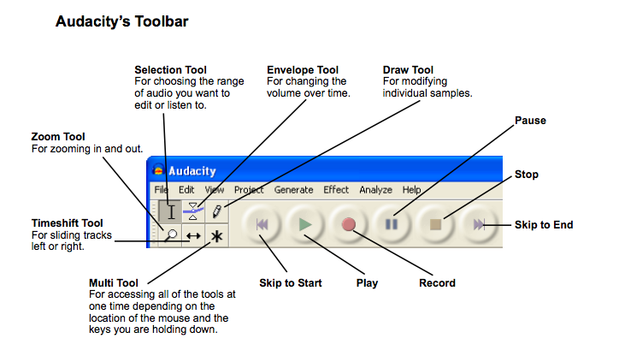
Be sure input/output are set according to what you are using:
Audacity Shortcuts
Zoom shortcuts
- Zoom in: Control+1
- Zoom out: Control+3
- Zoom to normal: Control+2
- Fit timeline: Control+F
- Fit tracks vertically: Shift+Control+F
- Zoom with mouse: Control + Scroll
Rename or Label Your Tracks
- Select an area and Control+B to label that segment
Or Tracks>New Tracks> Label Track and you can just click on the track to label
- Control+M to label a spot while playing
- Rename Recorded Lines: Click by the X on the track and click Name…
Cut/Trim Tools NOTE: When editing, be sure you are “stopped” and not on “pause”
- Control+ I Split Track
- Control+X Cut
- Control+V Paste
- Control+D Duplicate
- Delete Delete selected audio
Popular Effects
- Noise Removal (get noise profile on ambient sound; then, use step 2 on the rest)
- Normalize (-1 is a good level)
- Bass and Treble (increase each by a tad)
- Fade In/Fade Out (used often with music tracks at head and tail)
- Change Pitch (chipmunk or deep voice)
- Change Tempo (affects speed but does NOT affect pitch)
- Change Speed (speeds up/chipmunk or slows down/deepen at same time)
- Repeat (to loop a section; turns it into one long file)
- Echo (need to select past the actual sound, so always record some empty)
- Vocoder (robot voice; settings—20, 180, 0, 0, 80, 80)
Other Stuff
Listening
- Mute All Tracks Control+U
- Unmute All Tracks Control+Shift+U
- Listen To Audio in Fast FW Playback Speed Slider (top right) 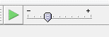
Random NOTE: You MUST export to WAV or MP3 to use the audio in projects!!!
- Generate Menu: Noise (white noise), Click Track (beat), Silence
- Exporting: Can export to WAV uncompressed format or MP3 format, which allows you to add metadata. If using MP3 format, it may ask you to browse to find the Lame encoder the first time (on Z drive in Multimedia folder in Lame for Audacity folder).
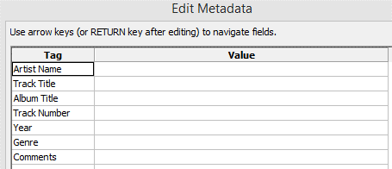ID3 tags for metadata on MP3

