Write a “song” to the tune of the Brady Bunch theme song. You will video clips (on solid backgrounds) of people looking around at each other, etc. You may work with a group of four for theme and videotaping purposes, but each person will have to edit and submit their own project. Other suggestions would be your BFFs, family members, your band, or even the many faces of “you” and you could wear disguises for each clip. Have fun with this and make it entertaining!
Step 1
Listen to thebradybunch.wav and make up your own lyrics to go with it. Write your lyrics below. The “real” Brady Bunch lyrics are:
Theme Song Lyrics:
"The Brady Bunch" by Frank DeVol and Sherwood Schwartz
Here's the story of a lovely lady _______________________________________
Who was bringing up three very lovely girls. _______________________________________
All of them had hair of gold, like their mother, _______________________________________
The youngest one in curls. _______________________________________
Here's the store, of a man named Brady, _______________________________________
Who was busy with three boys of his own, _______________________________________
They were four men, living all together, _______________________________________
Yet they were all alone.
Till the one day when the lady met this fellow _______________________________________
And they knew it was much more than a hunch, _______________________________________
That this group would somehow form a family. _______________________________________
That's the way we all became the Brady Bunch. _______________________________________
The Brady Bunch, _______________________________________
That's the way we all became the Brady Bunch. _______________________________________
HINT: Listen to the song in WMP while you are singing to keep the timing. Sing the song in your group – just have fun with it (I will help sing too if you would like)!

Step 2
Record your song in Audacity, import the background music, and export as an mp3 file. This will be your audio file for the project. Save in your Brady Bunch folder on the M: Drive.

Step 3
Download the Brady Bunch font from http://www.dafont.com/brady-bunch.font - see directions for downloading fonts. You will need this later when you add your title.
Step 4
Plan your video clips in the grid below – you will need at least 8 video clips plus a title in the center.
Video 3 | Video 1 | Video 6
Video 4 | TITLE  The ______________ Bunch | Video 7
Video 5 | Video 2 | Video 8

Step 5
Shoot your video clips, convert, and save to your Brady Bunch folder on the M: Drive – import all 8 videos into Movie Maker and add your Title as the ninth clip.
Step 6
Go to the following website and download the PIP (picture in picture 15 day trial) – DO NOT DOWNLOAD UNTIL ALL OF THE ABOVE STEPS HAVE BEEN COMPLETED.
http://rehanfx.org/pipplus.htm

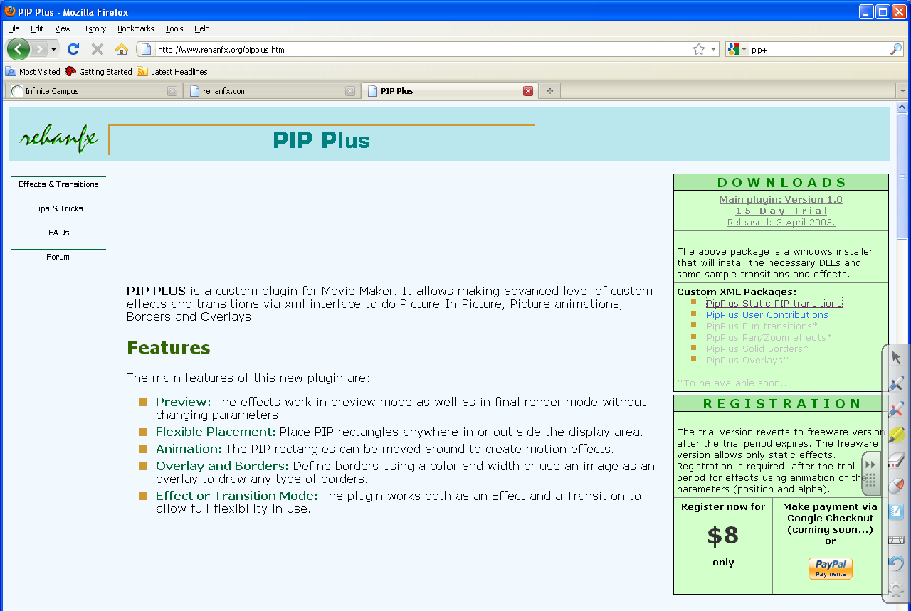
Download the 15 day free trial

http://www.windowsmoviemakers.net/Forums/ShowPost.aspx?PostID=23595
Copy and paste this code into notepad and save as: brady.xml (choose all files as type) in C:/Program Files/Movie Maker/Shared/AddOnTFX folder
<TransitionsAndEffects Version="1.0" SpecialIconFileID="1033" SpecialIconResourceID="101">
<Effects>
<EffectDLL guid="{0BEDE179-3361-4eea-9058-11CBB1739D50}">
<Effect name="Brady Bunch Window" iconid="0">
<Param name="RectA" value=" 0.0, 0.00,0.00,0.334,0.334" />
<Param name="Background" value="0x000000" />
</Effect>
<Effect name="Brady Bunch Shift" iconid="0">
<Param name="RectA" value=" 0.0, 0.334,0.00,1.00,1.00" />
<Param name="Background" value="0x000000" />
</Effect>
<Effect name="Brady Bunch Drop" iconid="0">
<Param name="RectA" value=" 0.0, 0.00,0.334,1.00,1.00" />
<Param name="Background" value="0x000000" />
</Effect>
</EffectDLL>
</Effects>
</TransitionsAndEffects>

Copy and paste this code into notepad and save as: COMP.xml (choose all files as type) in C:/Program Files/Movie Maker/Shared/AddOnTFX folder
<TransitionsAndEffects Version="1.0">
<Transitions>
<TransitionDLL guid="{9A43A844-0831-11D1-817F-0000F87557DB}" >
<Transition name="Comp A add B" iconid="0" comment="DXCOMPFUNC_A_ADD_B">
<Param name="Function" value="9" />
</Transition>
</TransitionDLL>
</Transitions>
</TransitionsAndEffects>
Step 7
Drag all 8 videos onto the Storyboard – MAKE SURE you are in Storyboard view NOT Timeline.
Left click on the 1st clip; hold shift and left click on the last clip. Click View Video Effects, right click on the effect titled Brady Bunch Window and click add to Storyboard. This should add the effect to each clip on the Storyboard. Verify that each clip is now a smaller window in the upper left (click on each clip to preview).

Step 8
Find the effects titled Brady Bunch Shift (moves clip to the right – can add multiple effect to continue shifting to the right) and Brady Bunch Drop (moves the clip down – can add multiple effect to continue moving down) within the effects window. You will be using these for a while.
At this point you need to visualize where you want each window to be located. So if clip #1 stays in the upper left, leave it alone. If clip #2 is located to the right of clip #1, drag the Brady Bunch Shift effect onto that clip. The preview window should show you where it moved. Each window is still isolated by itself at this point.
Repeat the above step until all of the clips will appear where you want once you start merging. If the clip needs to shift twice, drag the effect twice. If it needs to drop...drag the Brady Bunch Drop effect.
The preview window will show you what you have done. Move all clips to the proper location. You will start merging the windows in the next step.
Moves clip right
Moves clip down

Step 9
Switch to the transition window (view video transitions). Find the Comp A add B transition. Drag that transition between clip #1 and clip #2, between clip #3 and clip #4, between clip #5 and clip #6 and between clip # 7 and clip # 8. There should NOT be and transitions between 2 & 3, 4 & 5, 6 & 7 and 8 & 9!

Step 10
7 - Go to timeline view and make sure that the clips are dragged across each other as to maximize the transition time, or your windows will not be merged for very long. View the movie so far. There will be short sections where the windows are isolated...but you should have extended periods where 2 windows will be on the screen together.

Make the movie (File/Save As Movie File) to your M: Drive/Brady Bunch folder
Import the movie into Movie Maker (a blank project).
Split the clip between transitions, clean up the movie where windows are isolated (except clip #9), and then repeat the method used until the timing is to your liking. You will have to do this at least four times (split clip, clean up, insert transition “comp a add b,” make movie, and import).
Let me repeat that last point; only two (2) clips at a time. So if you have 9 clips (including your title), you can combine 1 & 2, 3 & 4, 5 & 6, and 7 & 8 on the 1st pass, then combine 1-2 & 3-4 and 4-6 & 7-8 on the second pass then combine 1-2-3-4 & 5-6-7-8 on the 3rd pass, and finally combine 1-2-3-4-5-6-7-8 with clip 9 on the last pass.
This is the tricky part – PAY CLOSE ATTENTION when I demonstrate.
HINT: You may want to listen to the audio file while you are editing to ensure squares will appear at proper time during the song.
Import the audio file and make the final movie! Upload to Schooltube and turn in scoring guide!
You will be graded on the following criteria:
 | CHECK OFF AS YOU COMPLETE
 | Planning evident (lyrics written out and video grid filled in) | /10
 | At least eight (8) video clips) | /16
 | Title slide typed in Brady Bunch font | /10
 | Theme song; your lyrics with instrumental | /10
 | Video clips coordinate with song lyrics | /10
 | Brady Bunch Effect utilized successfully | /10
 | Quality of finished video; time and effort, very creative | /10
 | Saved as Movie File (wmv) and uploaded to Schooltube | / 4
TOTAL POINTS POSSIBLE |  | /80

Name: ___________________________________________________________________

