MULTIMEDIA—GREEN SCREEN POP-UP VIDEO PROJECT
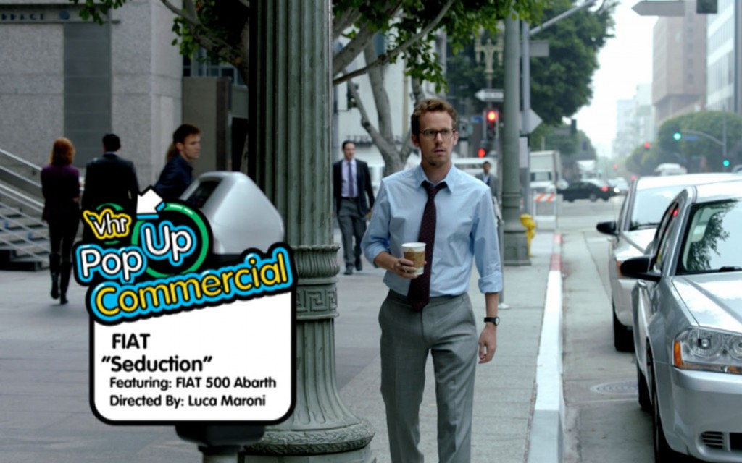
Write an outline (or word for word) of what you plan to talk about and practice first! Attach script/outline.
Requirement | Details for Grading | Points | Deduct
Must include YOU in front of the green screen and you should talk about yourself or some topic you are excited about… fast. | AUDIO: Quality of oration, understandability, “fun” of tone, and volume (gotta hear ya!) --10 pts  VIDEO: Background keyed out in Premiere (quality of keying) --20 pts | 30
Motion background is used behind subject | Should not be too distracting, but should be fun to match overall theme and should be high quality | 10
Acting/Emotion | Despite your eagerness to talk on camera, this should be upbeat… even obnoxious. Act! | 10
Pop-up Video Logo | We will have our own “JHS PopUp Video logo” on the drive. Use it in the bottom corner at the beginning as the video fades in from back. | 5
Pop-ups | During your talking, you should have random photos, clipart, icons, text boxes, etc. pop up to compliment what you are saying. These should include some audio “pop” or bubble sound that happens simultaneously. You should have a minimum of 20 pop ups! How many? | 40
Background Music | Some light (not too loud) background music should be added. | 5
Logo | Video fades to personal logo on black. | 5
Length | Video should be 60 OR 90 seconds in length. | 5
Overall Quality | Video should be entertaining and help me learn something new about you or something you are passionate about. Keep it light and fun (stories from your youth, favorite things, pet peeves, ideal future, hope and dreams, etc.). | 15
TOTAL POINTS |  | 125
Upload to SchoolTube for Grading—Name it PopUp Video JHS Your Initials
Name:_____________________________

